The Future for Ink and Laser Cartridges: A Lyra Forecast Exclusive (11/3/2005)
The inkjet and laser cartridge markets have changed in many ways over the last few years, but one thing has remained constant: the growth of the aftermarket. Printer OEMs have seen their share of worldwide cartridge shipments and revenue steadily decline, lost to aftermarket suppliers, and Lyra expects this trend to continue over the next several years.
Lyra has provided Recharger Magazine with this exclusive look inside Lyra’s newly revamped Cartridge Demand Advisory Service (CDS). The CDS features Lyra’s latest aftermarket ink and toner cartridge forecasts, insight into trends influencing the future of each market segment, a quantitative analysis of cartridge demand by SKU, and much more. The following is just a small snippet of data from that service. See the end of the article for more information on the CDS and how it can help your firm increase its profitability.
Aftermarket Share of Laser Cartridge Market Will Grow
Lyra forecasts that worldwide shipments of toner cartridges for use in monochrome laser printers and MFPs will peak in 2007 and then decline through 2009 (see Figure 1). Shipments of monochrome cartridges are expected to decrease gradually as more users replace aging monochrome devices with color laser printers and MFPs.
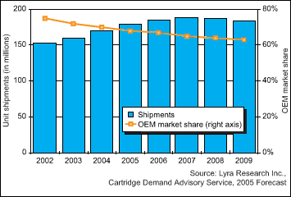
Figure 1
Printer OEMs’ share of the monochrome laser cartridge market has declined steadily and is expected to fall from 70 percent of worldwide cartridge shipments in 2004 to 63 percent in 2009. Lyra expects that aftermarket vendors will see their share of worldwide laser cartridge shipments increase steadily as more users become aware of aftermarket alternatives to OEM cartridges and trust in aftermarket brands increases.
Laser Engine Manufacturers for the Aftermarket to Watch
Many aftermarket laser cartridge vendors focus on developing monochrome cartridges for Canon engines in order to target HP’s enormous installed base of monochrome laser printers and MFPs, which use Canon engines. However, a growing number of aftermarket suppliers are differentiating themselves by offering monochrome cartridges for other laser engine manufacturers such as Samsung and Brother. In fact, Lyra expects to see worldwide shipments of aftermarket cartridges for use in Samsung monochrome lasers increase at a compound annual growth rate (CAGR) of 22 percent between 2004 and 2009. Meanwhile, shipments of aftermarket cartridges for use in Brother monochrome laser printers and MFPs will increase at a 9 percent CAGR over the same period.
Aftermarket Laser Cartridge Pricing Trends
Lyra’s primary research reveals that almost half of North American business buyers say they would purchase a comparable-quality aftermarket toner cartridge if it cost 30 percent less than the OEM cartridge. Currently, most aftermarket monochrome laser cartridges sell for 22 to 27 percent less than OEM cartridges (with the exception of Lexmark cartridges, which require a steeper discount because of the OEM’s Prebate or Return Program) (see Figure 2).
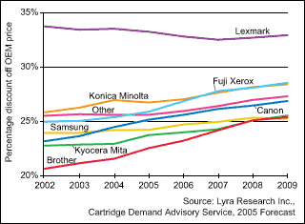
Figure 2
Lyra anticipates that aftermarket laser cartridges will approach a 30 percent discount in 2009, making them much more appealing to a wider variety of buyers. Despite the continuing pressure to discount prices, aftermarket vendors are expected to see their share of worldwide revenue from the sale of monochrome laser cartridges grow through 2009.
Aftermarket Inkjet Cartridge Shipments Will Show Significant Growth
Lyra divides the aftermarket inkjet cartridge market into several segments. A non-OEM inkjet cartridge is simply any cartridge designed for use in a specific printer model that is manufactured by a firm other than the printer vendor. There are two different types of non-OEM cartridges: compatible cartridges and remanufactured cartridges. Compatible cartridges are produced by a manufacturer other than the printer OEM using newly manufactured components, while remanufactured cartridges contain OEM parts that have been cleaned and reused but are assembled and refilled by another manufacturer. Refilled inkjet cartridges are both OEM and non-OEM cartridges that have been refilled using a do-it-yourself refill kit or at a retail refill shop such as Cartridge World, Rapid Refill or Caboodle Cartridge.
Lyra forecasts that worldwide shipments of non-OEM cartridges will grow at a healthy rate over the next five years in spite of printer OEMs’ ever-changing cartridge technologies (see Figure 3). However, refilled inkjet cartridges are expected to exhibit even stronger growth between 2004 and 2009. Retail cartridge-refilling franchises are growing very rapidly in North America, Europe, and other parts of the world, and these franchises represent another option for consumers who are looking to reduce printing costs. Despite the strong growth forecast for refilled cartridges, refilled cartridges’ share of the market will remain relatively small compared with that of non-OEM cartridges.
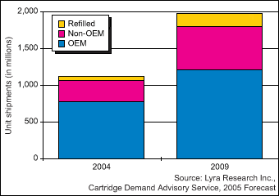
Figure 3
In 2004, of the four major inkjet printer vendors (Canon, Epson, HP and Lexmark), Epson suffered the most from worldwide growth in shipments of non-OEM and refilled cartridges, in part because of the firm’s shift from tricolor (or multicolor) to single-color inkjet cartridges (see Figure 4). In fact, only 61 percent of all inkjet cartridges shipped for use in Epson printers in 2004 were OEM cartridges. Canon is in a similar position, as only 62 percent of worldwide inkjet cartridge shipments for use in Canon devices were manufactured by the OEM. Both firms have a relatively high aftermarket share because aftermarket cartridges made for these brands are typically compatibles and therefore not dependent on the supply of empty cartridges. In contrast, because HP and Lexmark inkjet printers use integrated cartridges, many of the aftermarket cartridges used in these devices are remanufactured and thus dependent on the supply of empties. Remanufacturers often have a hard time finding a supply of empty cartridges, especially for newer SKUs, which leads to both a scarcity of remanufactured cartridges and higher prices.
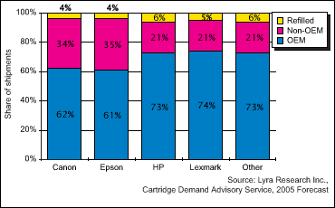
Figure 4
Lyra’s New Cartridge Demand Advisory Service (CDS)
The information included in the article comes from Lyra’s Cartridge Demand Advisory Service (CDS). Lyra recently launched this new service, which allows vendors to view demand for cartridges by SKU number, provides a forecast of inkjet and toner cartridge shipments and revenue, and includes inquiry privileges with a Lyra analyst. Lyra is aware that remanufacturers need detailed information at the SKU level to assist with product planning and development, marketing, and production. This advisory service was created and priced with remanufacturers in mind. The service is modular, and the inkjet and laser cartridge modules can be purchased separately.
Contact Brian Jones at (617) 454-2641 for details and a product demonstration.

